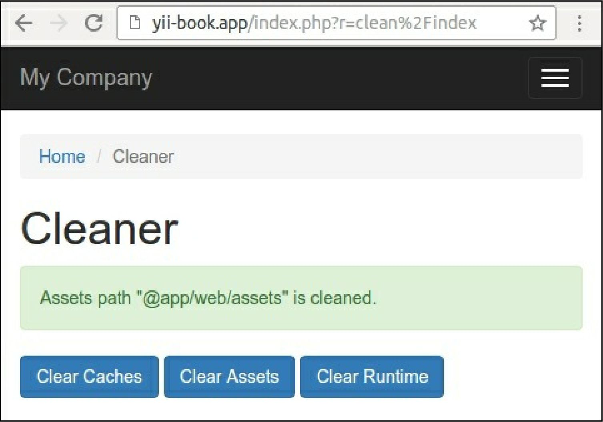

6. In case you use the yii2-app-advanced application template, just specify the correct paths in the configuration:

'controllerMap' => [

'clean' => 'app\cleaner\CleanController',

'assetPaths' => [

'@backend/web/assets',

'@frontend/web/assets',

],

'runtimePaths' => [

'@backend/runtime',

'@frontend/runtime',

'@console/runtime',

],

],

Now we can attach the controller to any application.

How it works...

When you are running an application and passing a route such as clean/index, prior to executing cleanController: : actionIndex, Yii checks if there is controllerMap defined. Since we have a clean controller defined there, Yii executes it instead of going the usual way.

In the controller itself we defined the assetPaths, runtimePaths, and caches properties to be able to connect the controller to applications with different directory and cache structures. We are setting it when